EXPERIMENT 3 — CANNY EDGE DETECTION
Your Experiment 3 is to read an image in Python and show its outline using the Canny function.
AIM
To read an image using Python and OpenCV and detect the edges or outlines of the image using the Canny Edge Detection method.
ALGORITHM
- Import the OpenCV library.
- Upload and read the input image.
- Convert the image into grayscale.
- Apply Canny Edge Detection.
- Display the original image.
- Display the detected edges.
- Save the output image.
PROGRAM
import cv2
from google.colab import files
from google.colab.patches import cv2_imshow

# Upload image
uploaded = files.upload()

# Read image
filename = list(uploaded.keys())[0]
img = cv2.imread(filename)

# Convert to grayscale
gray = cv2.cvtColor(img, cv2.COLOR_BGR2GRAY)

# Apply Canny Edge Detection
edges = cv2.Canny(gray, 100, 200)
# Display original image
print("Original Image:")
cv2_imshow(img)
# Display edge image
print("Canny Edge Detection:")
cv2_imshow(edges)
SAMPLE INPUT

OUTPUT
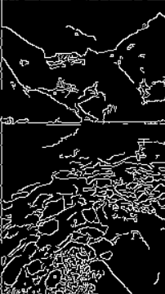
RESULT
Thus, the edges of the given image were successfully detected using the Canny Edge Detection method in Python and OpenCV.

